Fitness and Diet Tracker with Personalized Recommendations

CSA1012 – SOFTWARE ENGINEERING



SIMATS ENGINEERING
Saveetha Institute of Medical and Technical Sciences Chennai-602105
June 2026

INDEX
1. Introduction
- 1.1 Problem Statement
- 1.2 Objectives
- 1.3 Scope of the Study
2. Stakeholder and Challenge Analysis
- 2.1 Identified Stakeholders
- 2.2 Roles and Responsibilities
- 2.3 Key Challenges Faced by Stakeholders
3. Analysis of the Current System
- 3.1 Existing Approach/System
- 3.2 Strengths of the Current Approach
- 3.3 Limitations and Gaps
4. Proposed Software Solution
- 4.1 Overview of the Proposed System
- 4.2 System Architecture
- 4.3 Functional Modules
- 4.4 Functional Requirements
- 4.5 Non-Functional Requirements
5. Methodology / SDLC Justification
- 5.1 Selected Methodology
- 5.2 Justification for Selection
- 5.3 How It Supports Development and Maintenance
6. Expected Outcomes and Limitations
- 6.1 Expected Benefits/Outcomes
- 6.2 How the Solution Addresses Identified Challenges
- 6.3 Risks and Implementation Challenges
- 6.4 Future Enhancements
7. Conclusion

Fitness and Diet Tracker with Personalized Recommendations

- INTRODUCTION
The fitness and wellness industry has grown rapidly with rising awareness of preventive healthcare and lifestyle diseases such as obesity and diabetes. Smartphones and wearable devices now enable continuous health data collection, creating an opportunity for software systems to turn this data into personalized, actionable guidance.
1.1 PROBLEM STATEMENT
Existing fitness apps are fragmented — tracking either activity or diet in isolation, with little personalization based on age, weight, BMI, or health goals. There is no unified system combining activity, nutrition, and wearable data with personalized recommendations, reminders, and progress tracking. This project proposes a Fitness and Diet Tracker to close this gap.
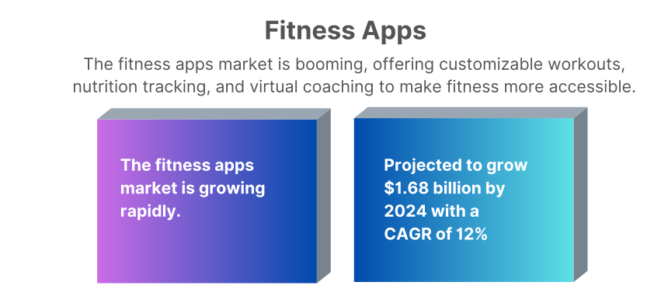

1.2 OBJECTIVES
The proposed system aims to:
- Develop a personalized fitness and diet management platform based on individual health data.
- Enable tracking of daily physical activity and nutritional intake.
- Generate AI-based, customized workout and diet recommendations.
- Integrate wearable device data for automatic health monitoring.
- Visualize user progress through interactive dashboards and reports.
- Send timely reminders for exercise, hydration, and meals.
- Ensure secure storage and management of sensitive health information.
- Promote sustained healthy lifestyle habits through continuous engagement.

1.3 SCOPE OF THE STUDY
- Design of a mobile/web-based application for individual end users
- Modules for activity logging, diet tracking, BMI calculation, and goal setting
- AI/rule-based recommendation engine for workouts and diet plans
- Integration with third-party wearable APIs (e.g., Google Fit, Apple HealthKit, Fitbit)
- Progress dashboards, notifications, and secure user authentication
STAKEHOLDER AND CHALLENGE ANALYSIS
2.1 IDENTIFIED STAKEHOLDERS
- End Users (individuals tracking fitness/diet)
- Nutritionists/Dietitians
- Fitness Trainers/Gyms
- Healthcare Providers
- Wearable Device Providers (Fitbit, Google Fit, Apple Health)
- App Developers/Administrators
- Data Privacy/Compliance Officers

2.2 ROLES AND RESPONSIBILITIES
- End Users: Log activity/diet, set goals, follow recommendations
- Nutritionists/Dietitians: Validate or refine AI-generated diet plans
- Fitness Trainers: Guide workout plans, monitor user progress
- Healthcare Providers: Advise on health conditions affecting recommendations
- Wearable Providers: Supply real-time activity/health data via APIs
- Developers/Admins: Build, maintain, and secure the platform
- Compliance Officers: Ensure health data privacy regulations are met
2.3 KEY CHALLENGES FACED BY STAKEHOLDERS
- Users: Low motivation, inconsistent logging, privacy concerns
- Developers: Integrating multiple wearable APIs, ensuring recommendation accuracy
- Healthcare Providers: Liability if AI advice conflicts with medical needs
- Admins/Compliance: Meeting data security and privacy regulations at scale

S. No. | Section | Contents to Include
1 | Introduction | Brief overview of the fitness and wellness industry, need for a fitness and diet tracking system, and purpose of the proposed software.
2 | Problem Understanding | Explain the problem in your own words, objectives of the system, and scope of the project.
3 | Stakeholder Analysis | Identify stakeholders, their roles and responsibilities, and the challenges they face.
4 | Current System Analysis | Describe the existing system, its strengths, limitations, and the gaps that the proposed system aims to solve.
5 | Proposed Software Solution | Overview of the proposed solution, major functional modules, functional requirements, non-functional requirements, and software engineering principles (modularity, scalability, maintainability, reliability, usability, and security).
6 | SDLC / Framework Justification | Select an SDLC model (e.g., Agile) and justify why it is suitable for the proposed system.
7 | Expected Outcomes | Explain the expected benefits of the system and how it addresses the identified problems.
8 | Limitations | Discuss implementation challenges, risks, and limitations of the proposed solution.
9 | Future Enhancements | Suggest features or improvements that can be added in future versions.
10 | Conclusion | Summarize the problem, proposed solution, and expected impact of the system.

3. ANALYSIS OF THE CURRENT SYSTEM
3.1 EXISTING APPROACH/SYSTEM
At present, individuals manage their fitness and diet through a mix of manual methods and disconnected digital tools. Many people track meals and workouts using notebooks or spreadsheets, relying on self-discipline and memory rather than structured data. Others use single-purpose mobile applications — such as calorie counters, step trackers, or workout logs — that function independently of one another, with no shared data flow between them. Wearable devices like fitness bands and smartwatches are increasingly common and generate continuous activity and health metrics (steps, heart rate, sleep), but this data is often confined to the device manufacturer's own app rather than being integrated into a broader health management system. For personalized guidance, individuals typically depend on in-person consultations with certified nutritionists, dietitians, or personal trainers, who manually assess the client's health data and design customized plans. While effective, this model is time-intensive, expensive, and difficult to scale to a large population of users.

3.2 STRENGTHS OF THE CURRENT APPROACH
- Expert-driven accuracy: In-person consultations with nutritionists and trainers provide medically sound, professionally validated guidance tailored to the individual.
- Simplicity of single-purpose apps: Existing calorie counters and step-tracking apps are generally easy to use for their specific, narrow function.
- Reliable raw data from wearables: Wearable devices are effective at capturing accurate physiological metrics such as heart rate, step count, and sleep duration.
- Established user trust: Many users already trust and are familiar with mainstream fitness apps and wearable brands, lowering the barrier to adopting a connected ecosystem.
3.3 LIMITATIONS AND GAPS
- Lack of personalization at scale: Most digital tools provide generic recommendations that do not account for an individual's BMI, medical history, or specific fitness goals, while personalized expert guidance cannot scale cost-effectively to large numbers of users.
- Data silos: Activity data, dietary logs, and wearable metrics are captured in separate systems that do not communicate with one another, preventing a holistic view of a user's health.
- Poor user engagement and adherence: Without automated reminders or motivational feedback, users frequently abandon manual tracking or app usage within weeks, undermining long-term health outcomes.
- Limited progress visualization: Existing tools rarely offer comprehensive, easy-to-interpret dashboards that combine activity, nutrition, and wearable trends over time.
- High cost and limited accessibility of expert consultation: Regular access to nutritionists or trainers is often financially or logistically out of reach for many users, restricting personalized guidance to a small segment of the population.
- No adaptive recommendations: Current systems typically do not adjust plans dynamically as a user's data (weight, activity level, adherence) changes over time.

Aspect | Current System | Gap Identified
Personalization | Generic fitness plans or costly expert consultations | Lacks personalized, data-driven recommendations and is not scalable
Data Integration | Health data is scattered across multiple apps and wearable devices | No centralized platform to provide a unified view of user health
User Engagement | Relies on users to manually track activities and stay motivated | No automated reminders, notifications, or engagement features
Progress Tracking | Basic charts or manual tracking methods | Does not provide comprehensive visualization of overall fitness progress
Cost & Scalability | Personalized guidance requires expensive trainers or nutritionists | Difficult to provide affordable personalized services to a large number of users
Adaptability | Workout and diet plans remain fixed after creation | Cannot dynamically adjust recommendations based on user progr

4. PROPOSED SOFTWARE SOLUTION
4.1 OVERVIEW OF THE PROPOSED SYSTEM
The proposed system is a unified Fitness and Diet Tracker that consolidates activity monitoring, nutrition logging, wearable device data, and personalized recommendations into a single platform. Rather than treating fitness and diet as separate concerns, the system builds a complete profile of each user — combining their physical attributes (age, weight, height, BMI), health goals, and real-time activity data — to generate adaptive workout and diet recommendations. The platform continuously updates its suggestions as new data is logged or synced from wearable devices, addressing the personalization and data-silo gaps identified in the current system. An intuitive dashboard visualizes progress over time, while automated reminders encourage consistent engagement, directly targeting the adherence problem seen in existing tools.

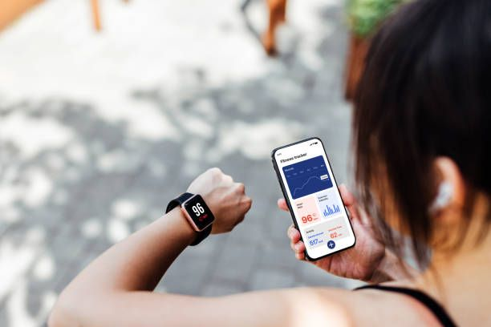
4.2 SYSTEM ARCHITECTURE
The system follows a layered, client-server architecture:
- Presentation Layer: Mobile/web application interface for logging data, viewing dashboards, and receiving notifications
- Application Layer (Backend/API): Handles business logic — user authentication, recommendation generation, notification scheduling
- Recommendation Engine: A separate service (rule-based or ML-based) that processes user data to generate personalized workout/diet suggestions
- Integration Layer: Connects to third-party wearable APIs (Google Fit, Apple HealthKit, Fitbit) to pull activity/health data
- Database Layer: Stores user profiles, logs, recommendations, and progress history securely

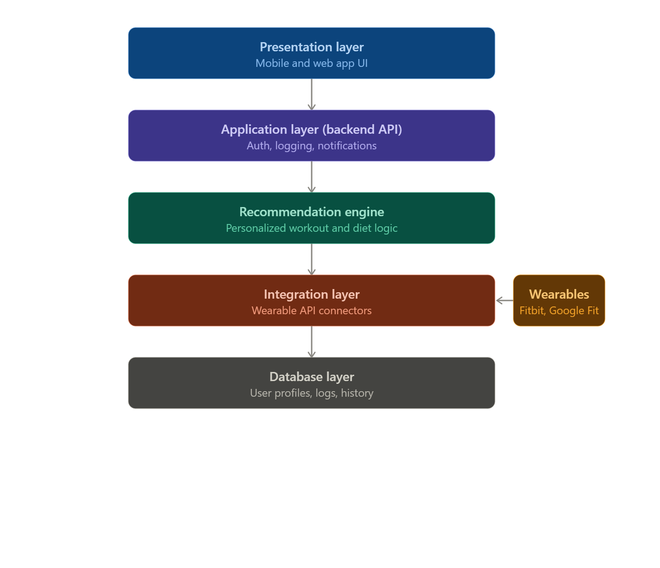
4.3 FUNCTIONAL MODULES
- User Profile & Onboarding Module: Collects age, weight, height, BMI (auto-calculated), health conditions, and fitness goals
- Activity & Nutrition Logging Module: Allows manual or automatic logging of workouts and meals
- Recommendation Engine: Generates personalized workout and diet plans based on user profile and progress
- Wearable Integration Module: Syncs data from connected devices automatically
- Dashboard & Analytics Module: Visual reports on weight trends, calorie balance, activity levels
- Notification/Reminder Module: Sends alerts for meals, hydration, and workouts
- Authentication & Security Module: Manages secure login, data encryption, and access control

4.4 FUNCTIONAL REQUIREMENTS
- The system shall allow users to register and create a health profile
- The system shall allow users to log meals and workouts manually
- The system shall sync data automatically from connected wearable devices
- The system shall generate personalized workout and diet recommendations
- The system shall display progress through visual dashboards
- The system shall send reminders for meals, hydration, and exercise
- The system shall allow users to update goals and health information
4.5 NON-FUNCTIONAL REQUIREMENTS
- Performance: Dashboard and recommendations should load within acceptable response times
- Scalability: System should support growing numbers of users without performance degradation
- Usability: Interface should be simple and accessible for non-technical users
- Reliability: System should handle wearable sync failures gracefully
- Security: Health data must be encrypted in transit and at rest
- Availability: System should maintain high uptime for continuous tracking
4.6 APPLICATION OF SOFTWARE ENGINEERING PRINCIPLES
- Modularity: Each functional module (logging, recommendations, notifications) is developed and deployed independently, simplifying updates and testing
- Scalability: Cloud-based backend allows horizontal scaling as user base grows
- Maintainability: Layered architecture separates presentation, logic, and data, making the codebase easier to update and debug
- Reliability: Automated testing and error handling ensure consistent performance, including graceful handling of wearable sync failures
- Usability: Clean, minimal-step interface encourages consistent daily logging
- Security: Role-based access control and data encryption protect sensitive health information, aligned with data privacy regulations
5. METHODOLOGY / SDLC JUSTIFICATION
5.1 SELECTED METHODOLOGY
The proposed system will be developed using the Agile (Scrum) methodology.
5.2 JUSTIFICATION FOR SELECTION
Agile is well-suited to this project because the system's core value — personalized recommendations — depends heavily on user feedback and iterative refinement, which a rigid, sequential model cannot accommodate. Requirements such as recommendation accuracy, dashboard usability, and reminder timing are likely to evolve as real users interact with the system. Agile allows the team to release a working core (profile creation, manual logging) early, then incrementally add wearable integration, the recommendation engine, and analytics in subsequent sprints, gathering feedback at each stage.
5.3 HOW IT SUPPORTS DEVELOPMENT AND MAINTENANCE
- Incremental delivery: Core tracking features can be released first, with AI recommendations and wearable sync added in later sprints
- Continuous feedback: Regular sprint reviews allow user feedback to directly shape recommendation logic and UI improvements
- Easier testing: Health-data-sensitive features (security, sync accuracy) can be tested incrementally rather than all at once at the end
- Adaptability: Changes in wearable API specifications or health guidelines can be absorbed within a sprint cycle rather than requiring a full redesign
- Reduced risk: Early and frequent releases surface integration issues (e.g., wearable API failures) before they compound

Factor | Agile (Selected) | Waterfall
Requirement stability | Evolves with user feedback | Assumes fixed upfront requirements
Delivery | Incremental (sprint-based) | Single final delivery
Feedback integration | Continuous | Only after completion
Suitability for this project | High — personalization needs iteration | Low — rigid, risky for evolving AI logic

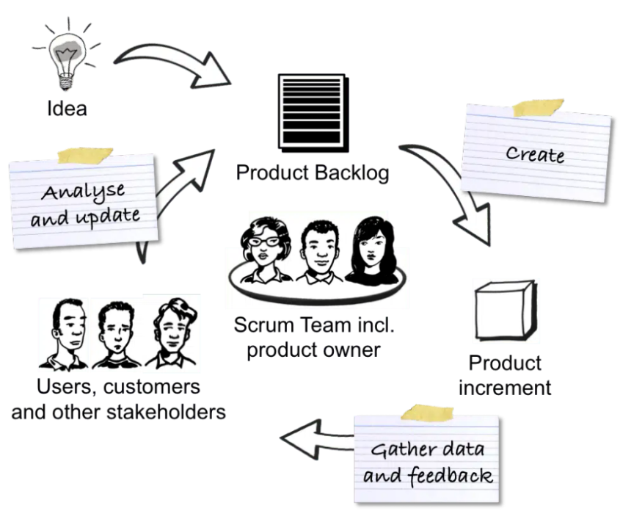
6. EXPECTED OUTCOMES AND LIMITATIONS
6.1 EXPECTED BENEFITS/OUTCOMES
- A fully functional, unified fitness and diet tracking application
- Personalized workout and meal recommendations based on individual health data
- Real-time health and activity monitoring through wearable integration
- Improved user engagement and adherence through reminders and notifications
- Clear, accurate visualization of progress over time
- Secure management of sensitive health-related data
- Better long-term adherence to fitness and nutrition goals
6.2 HOW THE SOLUTION ADDRESSES IDENTIFIED CHALLENGES
- Personalization directly resolves the generic-plan limitation of current single-purpose apps
- Unified data (activity + diet + wearable) eliminates the data-silo problem identified in Section 3
- Automated reminders address the poor-adherence gap caused by lack of engagement mechanisms
- Dashboards provide the comprehensive progress visualization missing from existing tools
- Digital delivery reduces dependency on costly, non-scalable in-person expert consultation
6.3 RISKS AND IMPLEMENTATION CHALLENGES
- Recommendation accuracy: AI/rule-based suggestions may not fully replace medical or professional dietary judgment, especially for users with existing health conditions
- Wearable API dependency: Third-party API changes, rate limits, or discontinuation could disrupt data sync
- Data privacy compliance: Handling sensitive health data requires strict adherence to privacy regulations, adding development and legal complexity
- User adoption and retention: Long-term engagement is not guaranteed even with reminders; users may still abandon the app over time
- Data accuracy dependency: Recommendations are only as reliable as the data users manually log
6.4 FUTURE ENHANCEMENTS
- AI-powered chatbot for real-time fitness/diet coaching
- Social/community features (challenges, leaderboards) to boost motivation
- Integration with certified nutritionists for plan validation within the app
- Predictive analytics to flag potential health risks based on long-term trends
- Support for a broader range of wearable devices and health platforms

Risk | Possible Mitigation
Inaccurate AI recommendations | Allow professional review/override of plans
Wearable API changes | Modular integration layer, multiple provider support
Data privacy compliance | Encryption, access control, regular audits
Low user retention | Gamification, personalized reminders

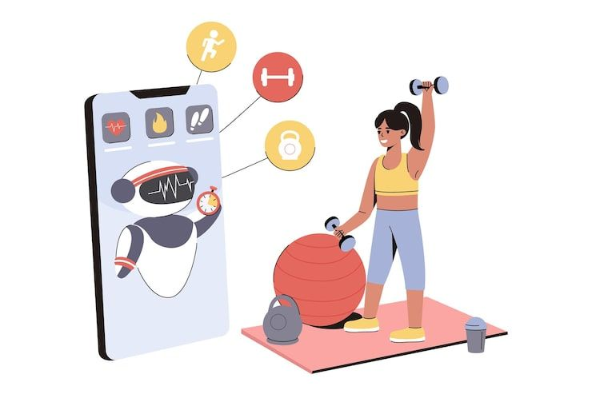
7. CONCLUSION
The proposed Fitness and Diet Tracker addresses a clear gap in the current fitness and wellness ecosystem — the lack of a unified, personalized, and data-driven approach to health management. By combining activity tracking, nutrition logging, wearable device integration, and AI-based recommendations into a single platform, the system moves beyond the fragmented, generic tools currently available. Applying core software engineering principles — modularity, scalability, maintainability, reliability, usability, and security — ensures the system is not only functional but sustainable and trustworthy for handling sensitive health data. Developed using an Agile methodology, the platform can evolve iteratively based on real user feedback, allowing its recommendation accuracy and user experience to improve over time. While challenges such as data privacy compliance and dependency on third-party wearable APIs remain, the proposed solution offers a scalable and practical path toward helping users achieve consistent, measurable improvements in their health and well-being.

